**CONTACT MANAGER USING**

**HTML CSS & JAVASCRIPT**

**Table of contents**

**Introduction** **3**

**Prerequisites** **3**

**Get started ✌** **3**

**First let’s create the skeleton of the ui** **4**

Add font awesome cdn 👇 4

Markup of contact list and contact 👇 4

Markup of add new contact form 👇 5

Output of above codes 👉 5

**Let’s add styling into ui 🎨** **6**

Creating css variables for colors, typography, visuals etc . 6

Basic styling 6

Adding styling into .container and contact .ListContainer 7

referencing –color, --bg-color, --filter1 css variable 7

Adding styling into contact and contactIcon 8

referencing –contactIconcolor, --deleteIconColor css variables 8

Adding styling into contact form referencing –bgcolor, 9

--filter, --inputTextColor css variables 9

Styling done 🎨 11

**Let’s start building feature for create new contact and render contact in the list , store contacts as a array object to localstorage** **12**

Function for adding new contact 12

Add a event listener submit to the form 12

Function for rendering new contact in display 13

Select contact list for appending all contacts in list 14

Select the current contact item in the DOM ( We’ll use 14

item for deleting contact from contact list later in this tutorial ) 14

Create new element article for contact ui 14

Save contacts data in browser local storage 17

Creating empty contacts array object 18

Set contacts to localstorage 18

Push new contactObject to contacts array object 18

Get contacts from localstorage to display contacts in contacts list 18

Let’s build functionality for deleting contact 19

Function for delete contact ( in deleteContact function we’re going to ) 19

Call deleteContact function 20

Tutorial written by sumit Creator of coding.batch 22

**Congratulation we have successfully** **22**

**created cool contact manager 🥳** **22**

**— The End —** **22**

Was it useful 🤔 let me know on instagram 22

— Get Source Code Here — 22

— Get Source with code comment — 22

# **Introduction**

In this tutorial we’re going to learn how to create a cool **contact manager**

using *html css and javascript* with the *dark light mode* functionality

# **Prerequisites**

# 

# 

# **Get started** ✌

The **contact manager** we’ll build in this tutorial will be pretty *cool*.

a user can **add or remove** a contact by entering enter after filling details

and delete contact by clicking delete icon

I’ll explain how to build each **feature**, but you must follow along by

**typing** the code and running it on your end to get the most out of this tutorial

*👇* ***Click here to get starter files***

[**](https://codesandbox.io/s/starter-contact-manager-5dduk?file=/index.html)

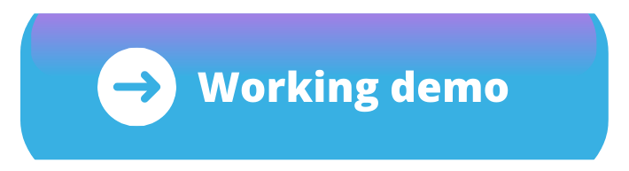

Just in case if your code didn't **work** as expected 😟

you can find the **working** code 😃 by ***clicking*** 👉

on **every end of steps**

I **recommend** using [**Codesandbox**](https://codesandbox.io/s/starter-contact-manager-5dduk?file=/index.html) while working **through this tutorial,** but feel

free to use other **code *playgrounds*** or your ***local* text editor** if you prefer.

**without wasting time let's get started** 🔰 👨‍💻

# **First let’s create the skeleton of the *ui***

## Add font awesome cdn 👇

We’ll use **font awesome icons** in this project for that we have to include font

awesome cdn in body tag you can create your own font awesome kit

| <**script** src="https://kit.fontawesome.com/dd8c49730d.js" crossorigin="anonymous"></**script**> |
| --- |

## Markup of contact list and contact 👇

***Note:- We creating this contact just for demo purpose we gonna use this markup in javascript while we creating functionality for rendering new contact in contact list with the same ui then we’ll remove this default contact from the contact list***

| <**section** class="ListContainer column">  <!-- here we'll render contacts -->  <**div** id="people" class="Contact_list"></**div**>  <!-- mark of contact -->  <**article** class="person">  <**img** src="https://avatars.githubusercontent.com/u/84091733?s=280&v=4">  <**div** class="contactdetail">  <**h1**><**i** class="fas fa-user-circle contactIcon"></**i**> coding batch</**h1**>  <**p**> <**i** class="fas fa-envelope contactIcon"></**i**> codingbatchig@gmail.com</**p**>  <**p**><**i** class="fas fa-phone-alt contactIcon"></**i**> 0000000000 </**p**>  </**div**>  <!-- delete contact button -->  <**button** class="delete-contact js-delete-contact">  <**svg** fill="var(--svgcolor)" xmlns="http://www.w3.org/2000/svg" width="24" height="24"  viewBox="0 0 24 24">  <**path** d="M6 19c0 1.1.9 2 2 2h8c1.1 0 2-.9 2-2V7H6v12zM19 4h-3.5l-1-1h-5l-1 1H5v2h14V4z" />  </**svg**>  </**button**>  </**article**>  <!-- mark of contact --> </**section**> |
| --- |

## Markup of add new contact form 👇

| <**form** autocomplete="off" class="js-form column"> <**div** class="name"> <**i** class="far fa-user"></**i**> <**input** type="text" id="fullName" placeholder="Enter name" /> </**div**> <**div** class="email"> <**i** class="fas fa-at"></**i**> <**input** type="email" id="myEmail" placeholder="Enter email" /> </**div**>  <**div** class="number"> <**i** class="fas fa-phone"></**i**> <**input** type="tel" id="myTel" placeholder="Enter number" /> </**div**>  <**div** class="img"> <**i** class="far fa-image"></**i**> <**input** type="url" id="imgurl" placeholder="Enter image url" /> </**div**> <**button** type="submit" class="submitbtn">Add Contact</**button**> </**form**> |
| --- |

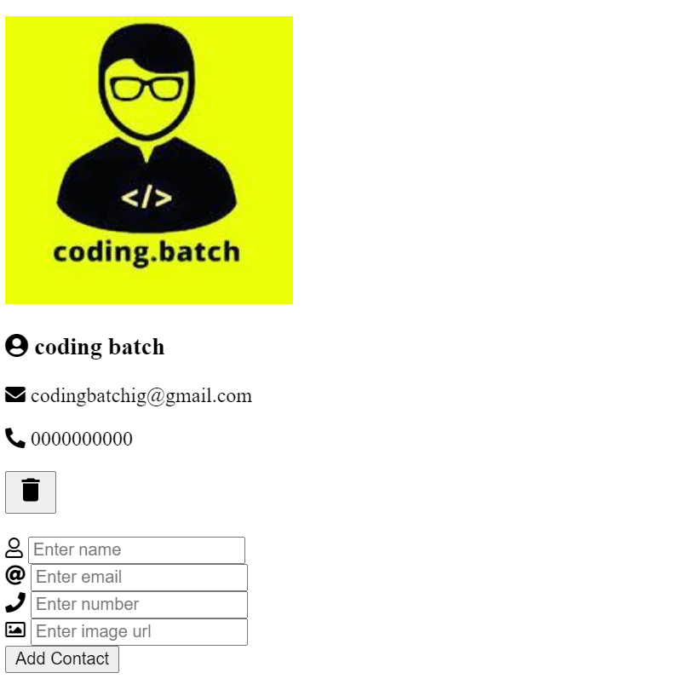

## Output of above codes 👉

[](https://codesandbox.io/s/step-1-zmy8d)

# 

# **Let’s add styling into ui** 🎨

## Creating css **variables** for *colors, typography, visuals* etc .

| :root {  --bg-color: #eef0f4;  --color: #333;  --togglebg: #333;  --contactIconColor: crimson;  --inputTextColor: #111;  --deleteIconColor: #111;  --filter: drop-shadow(-8px -8px 12px #ffffff)  drop-shadow(8px 8px 12px #c3c5c8);  --roundcolor: #eef0f4;  --toggleslider: #111;  --togglesliderColor: #111; } |
| --- |

## Basic styling

| html {  box-sizing: border-box; }  *, *::before, *::after {  box-sizing: inherit;  margin: 0;  padding: 0; }  body {  font-family: -apple-system, BlinkMacSystemFont, "Segoe UI", Roboto,  Oxygen-Sans, Ubuntu, Cantarell, "Helvetica Neue", sans-serif;  line-height: 1.4;  background: var(--bg-color); } |
| --- |

## 

## Adding styling into .container and contact .ListContainer

## referencing –color, --bg-color, --filter1 css variable

| .container {  margin: 0 auto;  padding-left: 10px;  padding-right: 10px;  color: var(--color);  margin-top: 5vh;  margin-bottom: 5vh;  display: flex;  flex-direction: row; }  .ListContainer {  width: 50%;  margin: 56px 30px 0 51px;  max-width: 500px;  border-radius: 0.25rem;  padding: 1.5rem 2rem;  border-radius: 16px;  background: var(--bg-color);  border: 12px solid var(--bg-color);  filter: var(--filter); } |
| --- |

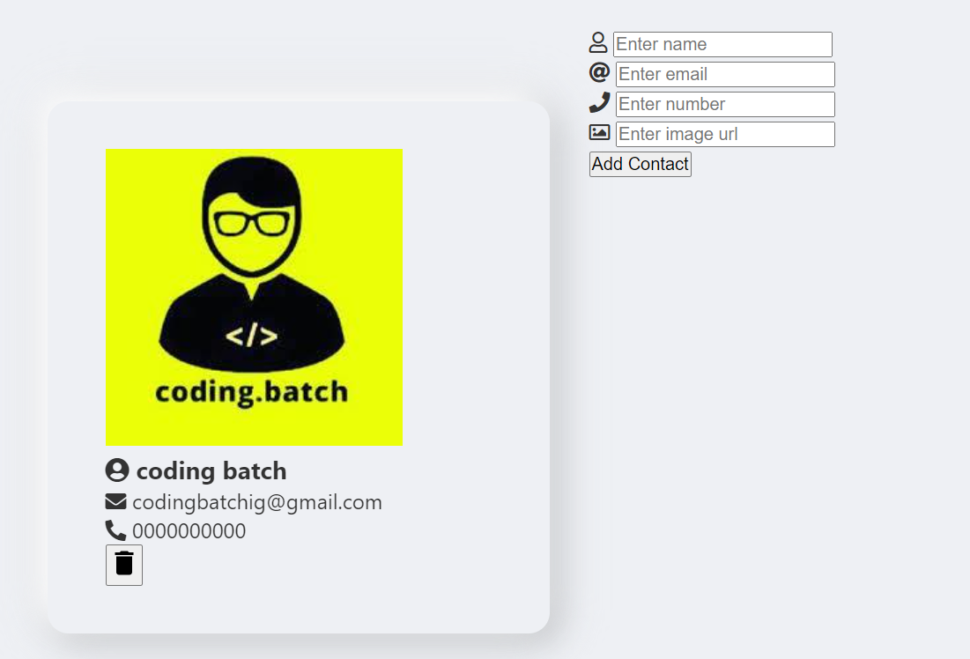

## 

## 

## 

## 

## Adding styling into contact and contactIcon

## referencing –contactIconcolor, --deleteIconColor css variables

| .person {  display: flex;  column-gap: 0.75rem;  margin-bottom: 1.5rem;  align-items: center; } .person img {  width: 75px;  height: 75px;  object-fit: cover;  border-radius: 50%;  box-shadow: 0 5px 15px rgba(0, 0, 0, 0.1); } .contactdetail {  margin-right: 5rem; } .contactIcon {  margin: 0 10px 0 5px;  font-size: 14px;  color: var(--contactIconColor); } .person h4 {  margin-bottom: 0.35rem; } .person p {  margin-bottom: 0; } .delete-contact {  border: none;  background-color: transparent;  outline: none;  cursor: pointer;  float: right;  display: block;  position: absolute;  right: 10%; } .delete-contact svg {  width: 30px;  height: 30px;  pointer-events: none;  fill: var(--deleteIconColor); } |
| --- |

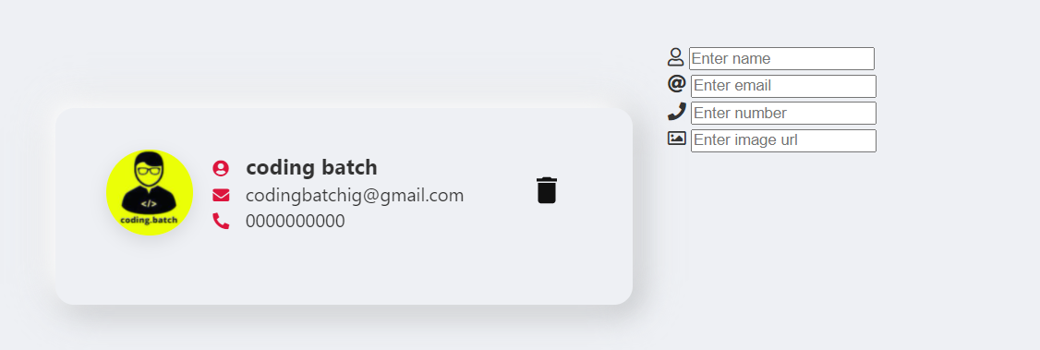[](https://codesandbox.io/s/step-4-gosj1)

## Adding styling into contact form referencing –bgcolor,

## --filter, --inputTextColor css variables

| form {  width: 50%;  left: 50%;  margin-top: 15%;  margin-left: 7%;  position: fixed; }  .name, .number, .email, .img {  display: flex;  justify-content: space-evenly;  margin-right: 30%;  align-items: center;  margin-bottom: 30px;  background: var(--bg-color);  border: 5px solid var(--bg-color);  filter: var(--filter); }  input[type="text"], input[type="email"], input[type="url"], input[type="tel"] {  width: 240px;  background: transparent;  border: none;  font-family: "Roboto", sans-serif;  font-size: 16px;  font-weight: 200px;  padding: 10px 0;  transition: border 0.5s;  outline: none;  color: var(--inputTextColor);  font-weight: bold; }  .submitbtn {  display: none; } |
| --- |

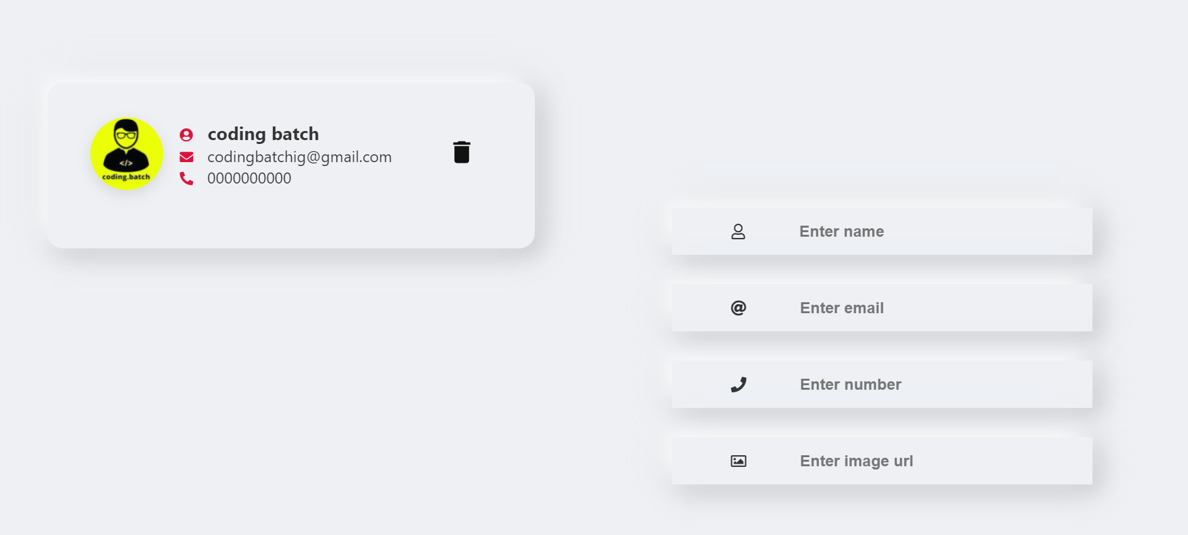

# 

# 

## 

## Styling done 🎨



Take a breather, and see the [complete code](https://codesandbox.io/s/step-5-x7eiq) at the end of this step

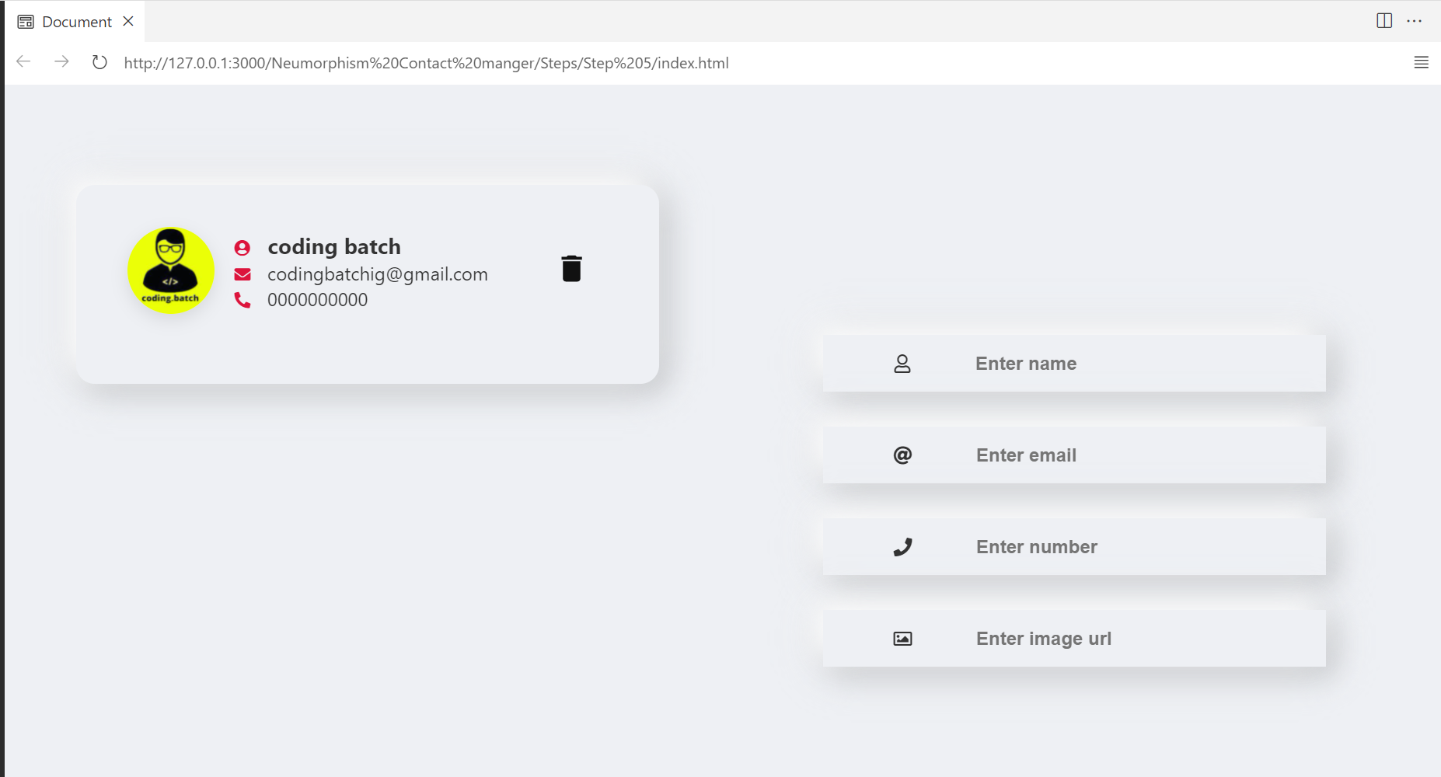

# **Let’s start building feature for create new contact and render contact in the list , store contacts as a array object to localstorage**

## Function for adding new contact

| function addContact(name, email, imageurl, contactnumber, id) {  // creating object for storing Contact details name email etc ..  const contactObject = {  name: document.getElementById("fullName").value,  email: document.getElementById("myEmail").value,  imageurl: document.getElementById("imgurl").value,  contactnumber: document.getElementById("myTel").value,  // we'll use this id to delete contact later in this tutorial   id: Date.now(),  };  console.log(contactObject); } |
| --- |

In above code we create a function for adding a new contact

* We created contactObject to store all contact detail as an object property
* In contactObject we getting a value of entered input values with their id by

using .value method & creating a id in contactObject using date.now method

* Console logged for demo purpose

### Add a event listener submit to the form

| const form = document.querySelector(".js-form"); form.addEventListener("submit", (event) => {  event.preventDefault();  addContact(); form.reset(); }); |
| --- |

In above code we added a event listener Submit to the form when form is submitted

* We will call our addContact() function for adding contact
* We using reset() method to reset form after submitting a contact

See the output in console log 👇



As you can see above after submitting a form by pressing enter we getting

a new contact as an object in the console log

But we want to render a contact in contactList to display in page to achieve this we have to create a renderContact() function above addContact() function

## 

## Function for rendering new contact in display

In this function we’re going to pass contact as a parameter to access contact details from contactObject eg: contact.name , contact.email etc ..

* We’re going to select list where we will appending a all new contact items
* Select the current contact item in the DOM
* Creating new element article (we’re going to use markup of contact what we created at beginning for demo purpose ) and append node in list

| function renderContact(contact) { } |
| --- |

### Select contact list for appending all contacts in list

| function renderContact(contact) {  const list = document.querySelector(".Contact_list");  } |
| --- |

### 

### Select the current contact item in the DOM ( We’ll use

### item for deleting contact from contact list later in this tutorial )

| function renderContact(contact) {  const list = document.querySelector(".Contact_list");  const item = document.querySelector(`[data-key='${contact.id}']`);  } |
| --- |

### 

### Create new element article for contact ui

1. Set the class and data-key attribute
2. Add html markup of contact

| function renderContact(contact) {  const list = document.querySelector(".Contact_list");  const item = document.querySelector(`[data-key='${contact.id}']`);  const node = document.createElement("article");  node.setAttribute("class", "person");  node.setAttribute("data-key", contact.id);  } |
| --- |

### 

We have to just cut and copy markup of contact ui to set the node.innerHTML

what we create at beginning for demo purpose

| function renderContact(contact) {  const list = document.querySelector(".Contact_list");  const item = document.querySelector(`[data-key='${contact.id}']`);  const node = document.createElement("article");  node.setAttribute("class", "person");   node.setAttribute("data-key", contact.id);  node.innerHTML = ` <img src="${contact.imageurl}"> <div class="contactdetail"> <h1><i class="fas fa-user-circle contactIcon"></i> ${contact.name}</h1> <p> <i class="fas fa-envelope contactIcon"></i> ${contact.email}</p> <p><i class="fas fa-phone-alt contactIcon"></i> ${contact.contactnumber} </p> </div> <button class="delete-contact js-delete-contact"> <svg fill="var(--svgcolor)" xmlns="http://www.w3.org/2000/svg" width="24" height="24" viewBox="0 0 24 24"> <path d="M6 19c0 1.1.9 2 2 2h8c1.1 0 2-.9 2-2V7H6v12zM19 4h-3.5l-1-1h-5l-1 1H5v2h14V4z" /> </svg> </button> `;  // appending a node in list  list.append(node); } |
| --- |

Yes here we successfully created our function for rendering a new contact in contact list

But as you can see we passed contact as a parameter of function to access the property of contactObject for displaying in contact ui

To archive that we have to call rendeContact() function in addContact function and pass contactObject object as an argument in renderContact function

Updated addContact as follows

| function addContact(name, email, imageurl, contactnumber, id) {  // creating object for storing Contact details name email etc ..  const contactObject = {  name: document.getElementById("fullName").value,  email: document.getElementById("myEmail").value,  imageurl: document.getElementById("imgurl").value,  contactnumber: document.getElementById("myTel").value,  // we'll use this id to delete contact later in this tutorial   id: Date.now(),  };  renderContact(contactObject); } |
| --- |

In above code we called renderContact function and passed contactObject as an

argument now we can use property of contactObject in renderContact() function

Now we can remove a default contact from list what we created at beginning

for demo purpose update markup of contact list as follows

| <**section** class="ListContainer column"> <**div** id="people" class="Contact_list"></**div**> <!-- mark of default contact removed --> <!-- mark of default contact removed --> </**section**> |
| --- |



As you can see above it’s work as expected

## 

But here we have one problem when we refresh the page all contacts cleared

See below



To keep it display we have to store data in localstorage for that we can

use javascript localStorage object

## Save contacts data in browser local storage

1. Create empty contacts array for storing all contacts as a array object in localstorage
2. To store contacts in localstorage we have to set contacts to localstorage
3. Push new contactObject to contacts after calling addContact()
4. Get contacts from localstorage to display contacts in contacts list

### Creating empty contacts array object

| let contacts = []; |
| --- |

### Set contacts to localstorage

We can set item to localstorage using localStorage.setItem method in renderContact()

Add below code line in above renderContact function

| // set item to localStorage to store data localStorage.setItem("contacts", JSON.stringify(contacts)); |
| --- |

### Push new contactObject to contacts array object

We have to push every new contactObject to contacts array object after adding contact

Add below code line within addContact

| contacts.push(contactObject); |
| --- |

### Get contacts from localstorage to display contacts in contacts list

To display contacts in contacts list we have to get the contact from contacts array after refreshing page to archive that we have to add event listener DOMContentLoaded and get the contacts from localStorage

| // adding a add event listener when content is loaded and showing stored data array on the screen document.addEventListener("DOMContentLoaded", () => {  const ref = localStorage.getItem("contacts");  if (ref) {  contacts = JSON.parse(ref);  contacts.forEach((contact) => {  renderContact(contact);  });  } }); |
| --- |

Now if we refresh page it’s keep the contacts in contact list

See below



## 

Take a breather, and see the [complete code](https://codesandbox.io/s/step-10-hyehk) at the end of this step

## Let’s build functionality for deleting contact

Do you remember we created id property in contactObject and set data-key attribute

to item in renderContact function now we’re going to use these property and item to

delete contact from contact list

### Function for delete contact ( in deleteContact function we’re going to )

* find the corresponding contactObject in the contacts array object
* Create a new object with properties of the current contactobject item and a `deleted` property which is set to true
* Remove the contactobject item from the array
* Render UpdatedContactObject

| function deleteContact(key) {  const index = contacts.findIndex((item) => item.id === Number(key));  const UpdatedContactObject = {  deleted: true,  ...contacts[index],  };  contacts = contacts.filter((item) => item.id !== Number(key));  renderContact(UpdatedContactObject); } |
| --- |

In above code we created function deleteContact with key parameter , to delete specific contact from contacts list we have to know which contact we wanted to delete for that we find the index of corresponding contactObject in the contacts array object using findIndex method when then when deleteContact() called remove the contactobject item from the array by filtering it out otherwise it will not delete contact item by click on delete button from localstorage

### Call deleteContact function

| const list = document.querySelector(".Contact_list"); // adding click event listner in list element list.addEventListener("click", (event) => {  // if event.target classlist have js-delete-contact  if (event.target.classList.contains("js-delete-contact")) {  // then get the data key of their parentElement which is article for our project by using dataset.key method  const itemKey = event.target.parentElement.dataset.key;  // then call our deletectContact function by passing itemKey as a argument  deleteContact(itemKey);  } }); |
| --- |

In above code we added click event listener to contact list if targeted event class list contains js-delete-contact then get the dataset.key of their parent Element and assign to itemkey and call deleteCount() function and passed itemKey as an argument

Finally let’s add remove method if UpdatedContactObject delete property true

Add below code in renderContact function

| if (contact.deleted) {  // remove the item from the DOM  item.remove();  return;  } |
| --- |

Now as you can see below we’re able to delete contact from contact list



## 

## Tutorial written by [sumit](https://www.instagram.com/codingsumit/) Creator of [coding.batch](https://www.instagram.com/coding.batch/)

# 

# Congratulation we have successfully

# created cool contact manager 🥳

# — The End —

## Was it useful 🤔 let me know on instagram

## — Get Source Code Here —

## — Get Source with code comment —